

National Textile University
Department of Computer Science
Subject
Mobile Application
Submitted to:
Rehan Sarwar
Submitted by:
Abdul Rehman
Registration Number
23-NTU-CS-1122
lab No.
03
Semester
6th

Lab Plan – 3
Lab Plan: Flutter Layout & Material Components
Objective
To master the implementation of specialized layout widgets and Material Design components to create polished, structured user interfaces.

Task 1: Custom Cards and Icon Layouts
Objective: Master the Card widget's visual properties and child arrangement.
- Activity: Create three Card widgets with varying color properties and elevation values.
- Requirement: Each card must contain a Row or Column of multiple Icon widgets with different sizes and colors.
Code:
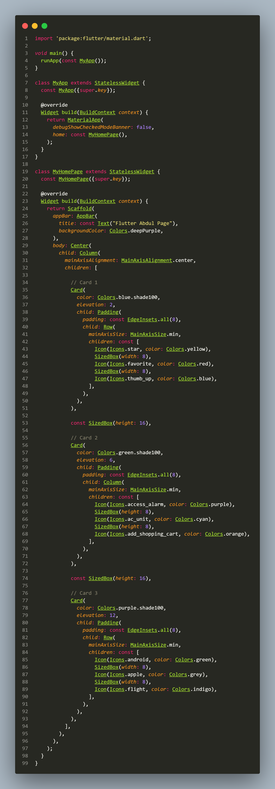
Output:
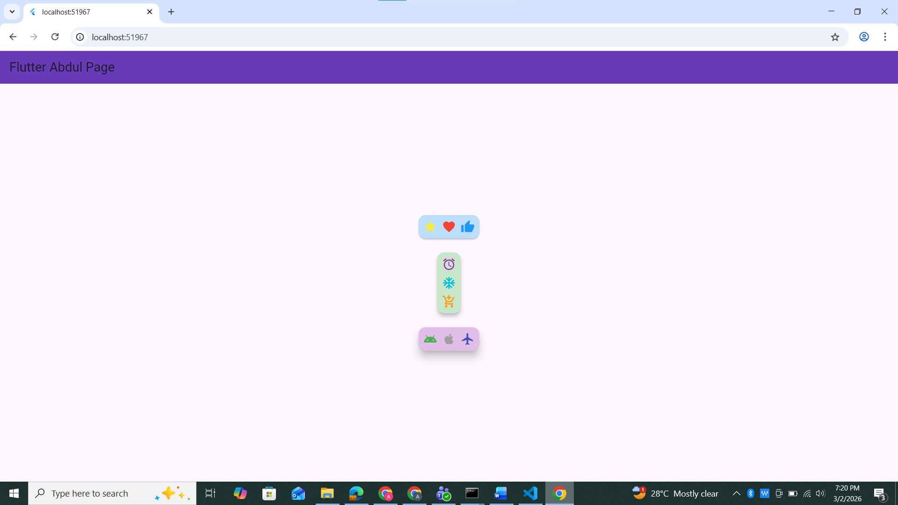

Task 2: Margin and Padding Implementation
Objective: Differentiate between internal (Padding) and external (Margin) spacing.
- Activity: Create a Container with a background color and implement the following:
  - All sides: Use padding: EdgeInsets.all(20.0).
  - Symmetric: Use margin: EdgeInsets.symmetric(vertical: 50.0, horizontal: 10.0).
  - Specific sides: Use EdgeInsets.only(left: 10) to add space only to the left.
- Code:
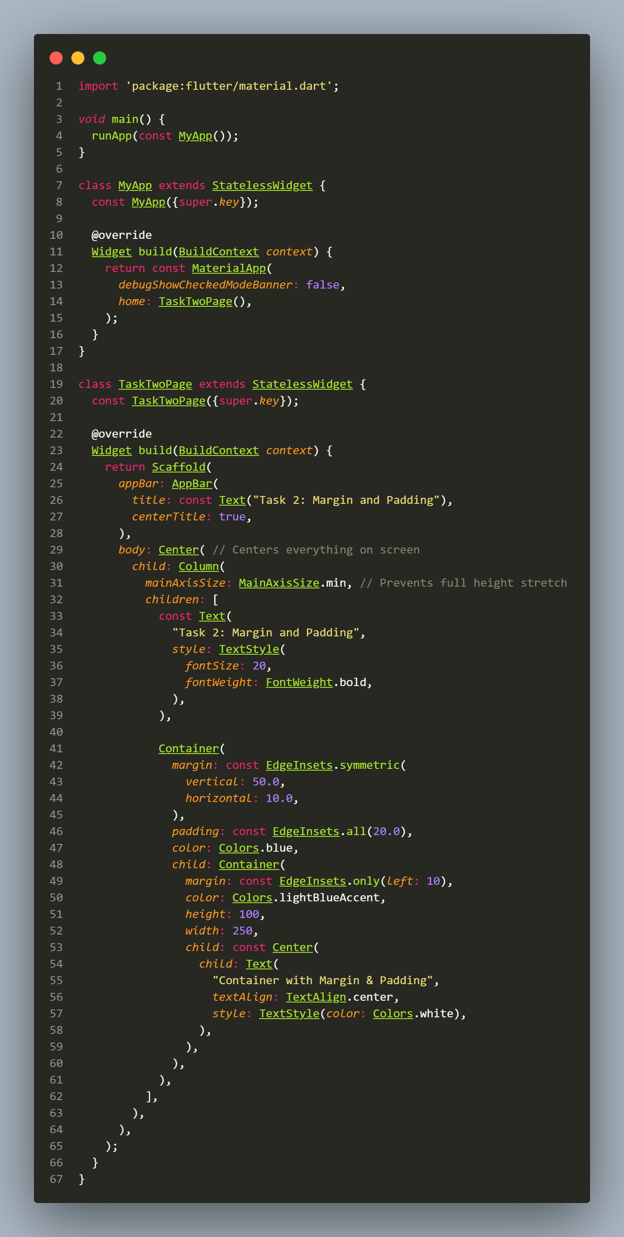
- Output:
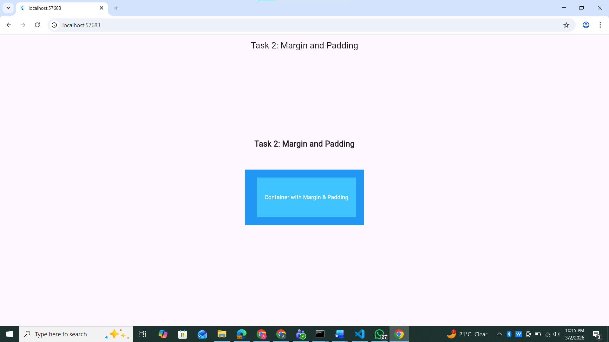

Task 3: Profile UI with CircleAvatar
Objective: Implement user identity visuals in different UI areas.
- Activity:
  - Place a CircleAvatar in the body that loads a profile image via NetworkImage.
  - Place a second CircleAvatar within the AppBar (typically in the actions or leading property) using AssetImage for a local file.
- Requirement: Ensure the avatar correctly represents a user profile or initials if the image fails to load.
- Code:
- 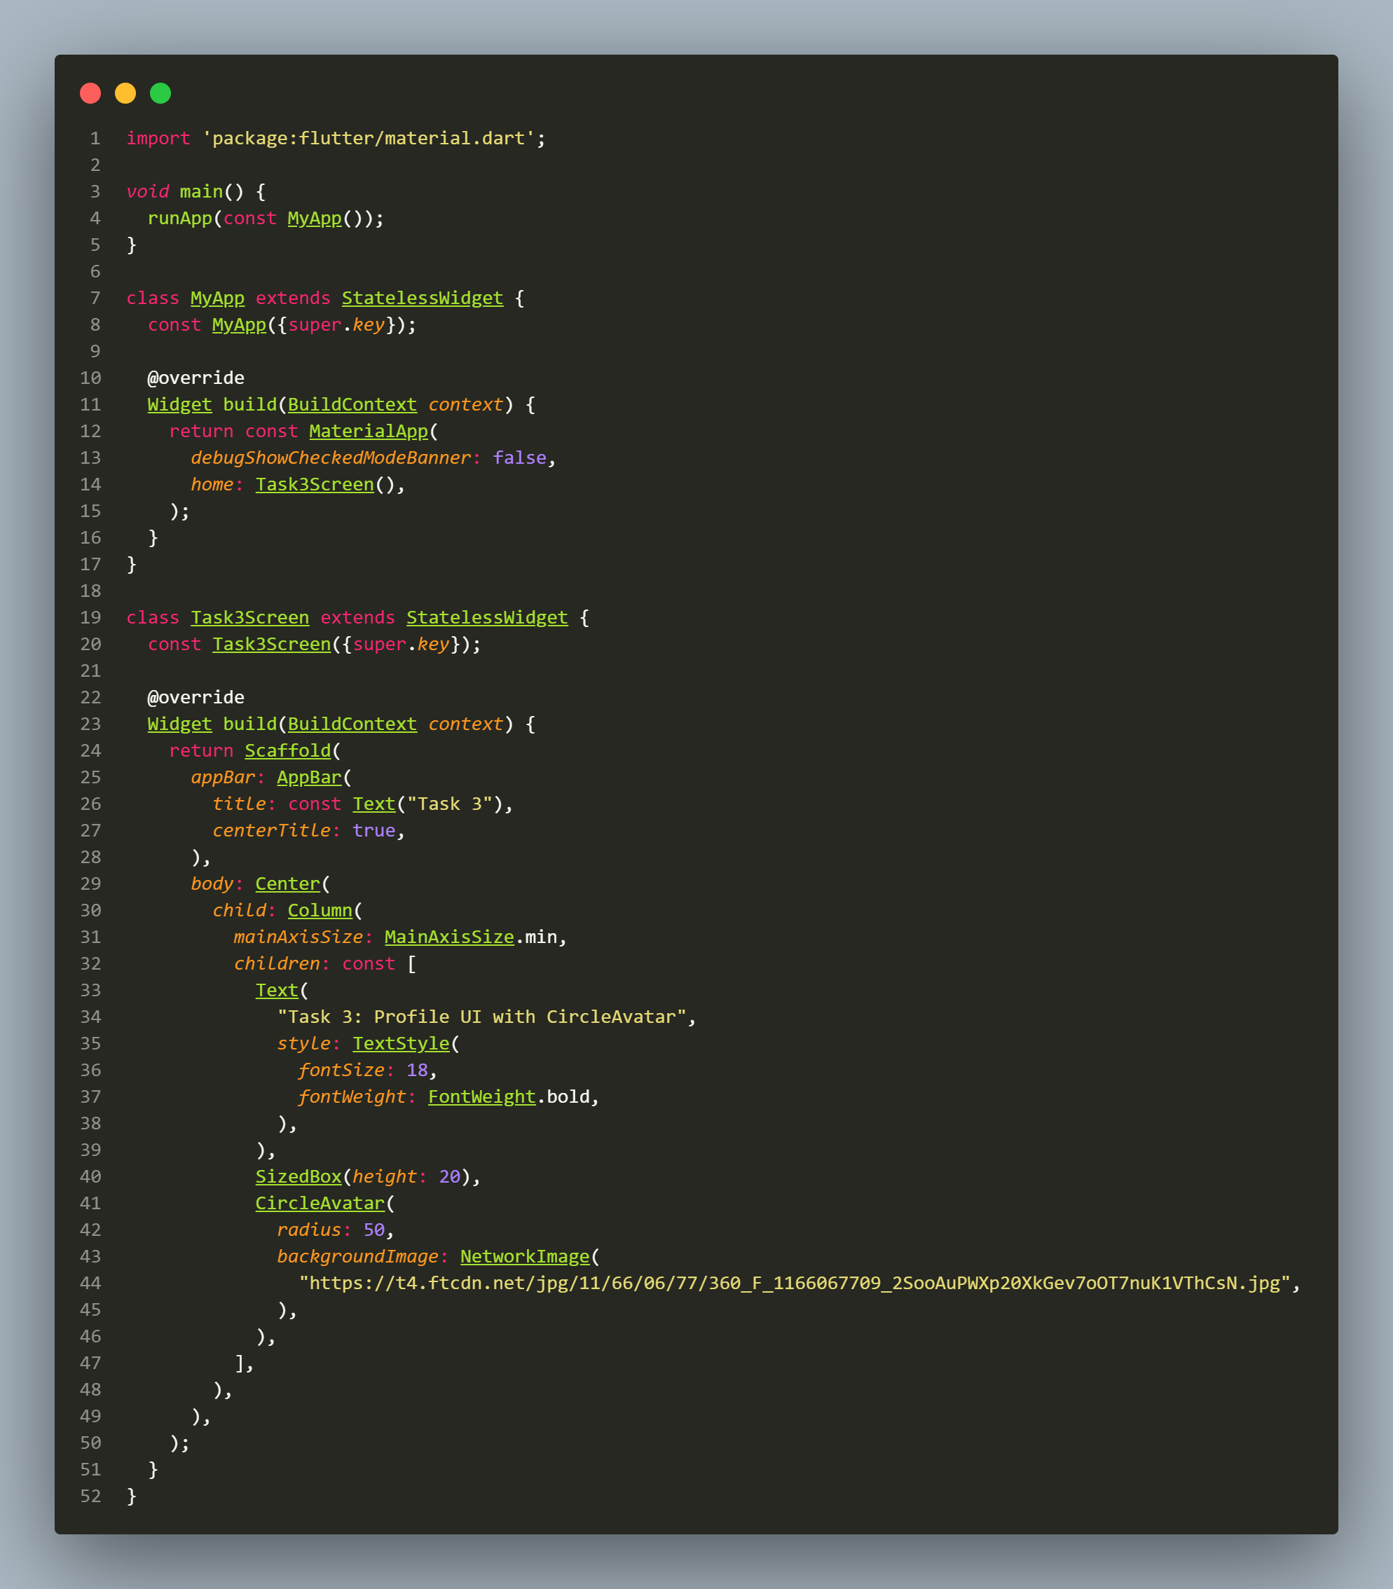
- Output:
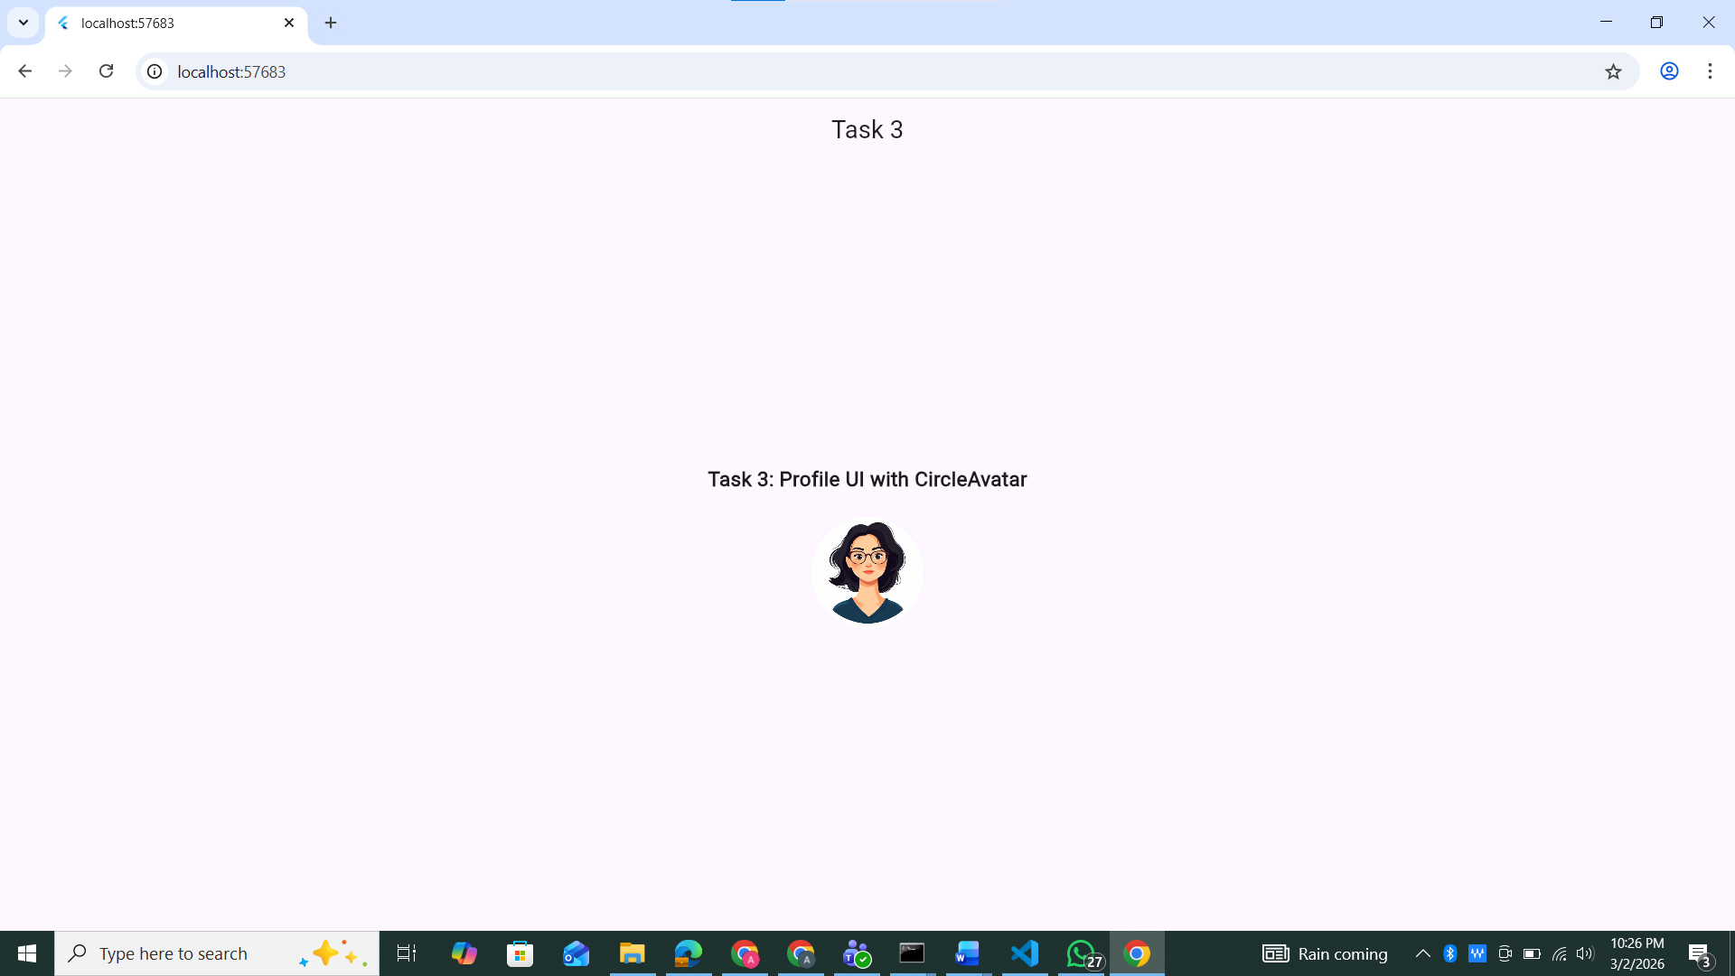

Task 4: Information Grouping with Card & ListTile
Objective: Use ListTile to create structured, repeatable UI elements.
- Activity:
  - Create a Card with rounded corners and an elevation shadow.
  - Inside the Card, nest a ListTile.
- Requirement:
  - Leading: Use an Icon or CircleAvatar. o Title: Contact name.
  - Subtitle: Registration No.
  - Variations: Create a second version with a different color scheme and a trailing icon.
Code:
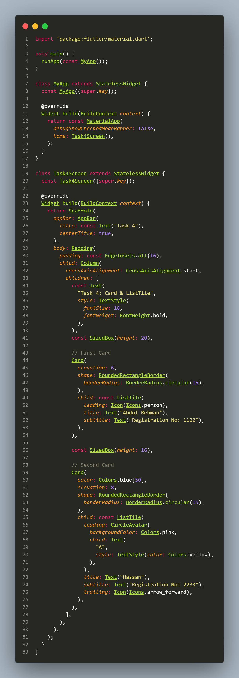

Output:
